F20- cst- 8117

Cross-Platform Web Design

Prof. Frank Emmanuel

Kazi Bubka

Student ID: 041012034 Email: bubk0001@algonquinlive.com

Assignment # 1

Building a Website

Table of Contents

Table of Figures 0

The Style Guide 1

1. Client 2

2. Style 2

3. Platform 2

4. Semantic Design Guide 3

5. Website Map 3

Deliverables 4

Marking Rubric 4

Submission 5

1. Client 5

2. Style 6

3. Platform 7

4. Semantic Design Guide 8

4.1 <head> 8

4.2 <body> 8

4.3 <div class= “wrapper”, “contactus”> 9

4.4 <nav> 9

4.5 <section class= “boxes”, “menu”, “menu-boxes”, “history”, “reservation”> 9

4.6 <table class= “contact”> 9

4.7 <footer> 9

5. Website Map 10

# Table of Figures

Figure 1 Splash image on landing page 6

Figure 2 Colour Palette 8

# The Style Guide

In the more organized development environments, especially in team environments, one of the most important documents is the style(design) and development guide. This is usually a living document, meaning that as the project changes the document is continually updated, usually by the team lead, to reflect the standards to be applied to the project. In the wonderful world of web development, often a style guide is used to detail common elements and ensure that colors and fonts adhere to the corporate branding of the client. It may also be combined with a development guide or programming reference which details coding standards and code base management practices. In our project we will create a simple style guide which can be used to coordinate design choices in the web development process.

Our style guide will be a short document with the following sections, please include a header for each section: Client, Style, Platform, Semantic Design Guide, Website Map. (You can reorder these sections as you see fit.) I am not looking for a large document with this project, two to three pages should suffice. I will detail what is required in each section below.

## Client

You will include a brief description of the client and the type of business that they perform (or how they wish to do business on the web). In a longer project, this is the section where you can identify contacts regarding client branding concerns. In real projects where client descriptions are provided, that content can be included here to ensure their consistency throughout the website.

## Style

In this section you will describe the kind of feeling or story that your design is meant to convey to the visitor. If there are notable examples of other businesses on the web that you are drawing on for inspiration this is a good place to mention those as well. This style will be the basis for the design you will implement on your web site.

## Platform

In a longer style guide this section is where you would discuss the implementation of responsive layout. Responsive layout establishes the rules as to how a website is displayed on small mobile devices, larger tablets, traditional computer monitors, and large monitors. As we have not covered responsive layout yet in our course we will assume that our client would like to build a website for users on traditional and laptop computers. In this section we will indicate that 1024x768 pixels is the new standard minimum resolution targeted by this webpage. In this section simply include something like the following sentence:

The website will target traditional monitor resolutions of **1024X768** and greater.

## Semantic Design Guide

Inside the semantic design guide you will list all the major semantic elements (header, nav, main, section, article, footer, etc.) for your web site. For each element you will provide the following information:

* The expected use of that semantic element
* Names (id=) used for any generic block element containers (<div>)
* Font choices used in that element
* Colour choices used in that element
* Standard images required for element (ie. logos) and their sizes
* Layout location for the element

If you would like to also include a graphical representation showing layout, that is perfectly acceptable. Also note that when you are creating the design of your website it is often a good idea to build the elements, style them with CSS so that they look like they belong, and then record these style choices in this section.

## Website Map

Finally, you will create a website map showing the various pages and using lines to connect them in terms of navigation elements (hypertext anchors). This map can simply use a box to represent pages and lines to show navigation. The navigation element should link to all major pages on the website and is reflected in the diagram by a link from the landing page to all the major pages. The rest of this standard navigation is implied.

# Deliverables

When your code is complete, make sure you zip up all the files created in this lab including a copy of all the images that you have used (project1.zip). It is important that you zip up your files rather than uploading them individually because BrightSpace will modify any unzipped web code that you submit. You should have the following files in your zip file:

* Style Guide Document
* All HTML pages (should be working when extracted)
* All images in subdirectory
* All linked CSS files (minimum of one)

Upload the zip file to BrightSpace.

# Marking Rubric

|  |  |
| --- | --- |
| **Task** | **Weight** |
| Pitch prepared (client details, style, 2 or more examples) | 4 |
| Pitch delivered professionally | 1 |
| Style Guide includes all required sections | 2 |
| Style Guide lists all major semantic elements | 2 |
| Style Guide provides appropriate colour, font, and layout information for each semantic element | 5 |
| Web map | 1 |
| Main CSS employed and complete | 4 |
| Web pages are all linked and employ design from style guide consistently | 5 |

# Submission

## Client

The fictional client chosen for this project is a local restaurant in Byward Market, Ottawa that offers Mexican cuisine. While the name and location of this restaurant is fictional, the images and descriptions of menu items have been provided by an acquaintance, who is a sous-chef at a restaurant in real life. These are coincidentally the items from their Fall menu of last year. The acquaintance shall henceforth be referred to by his discord username, El Jefe, who is also the namesake of our fictional restaurant.

I have asked El Jefe’s express permission to use his images and text for this academic project, and he has graciously provided me his consent. I have also clarified that while this project may be used as a sample of my work on my portfolio, it is not for commercial use.

If citation/references are required, I will be happy to reach out to El Jefe for one.

## Style

The intended style conveyed by this website is that of a casual, comfortable restaurant that serves authentic, locally sourced Mexican Cuisine.

A warm colour palette was chosen to complement the central splash image on the landing page:

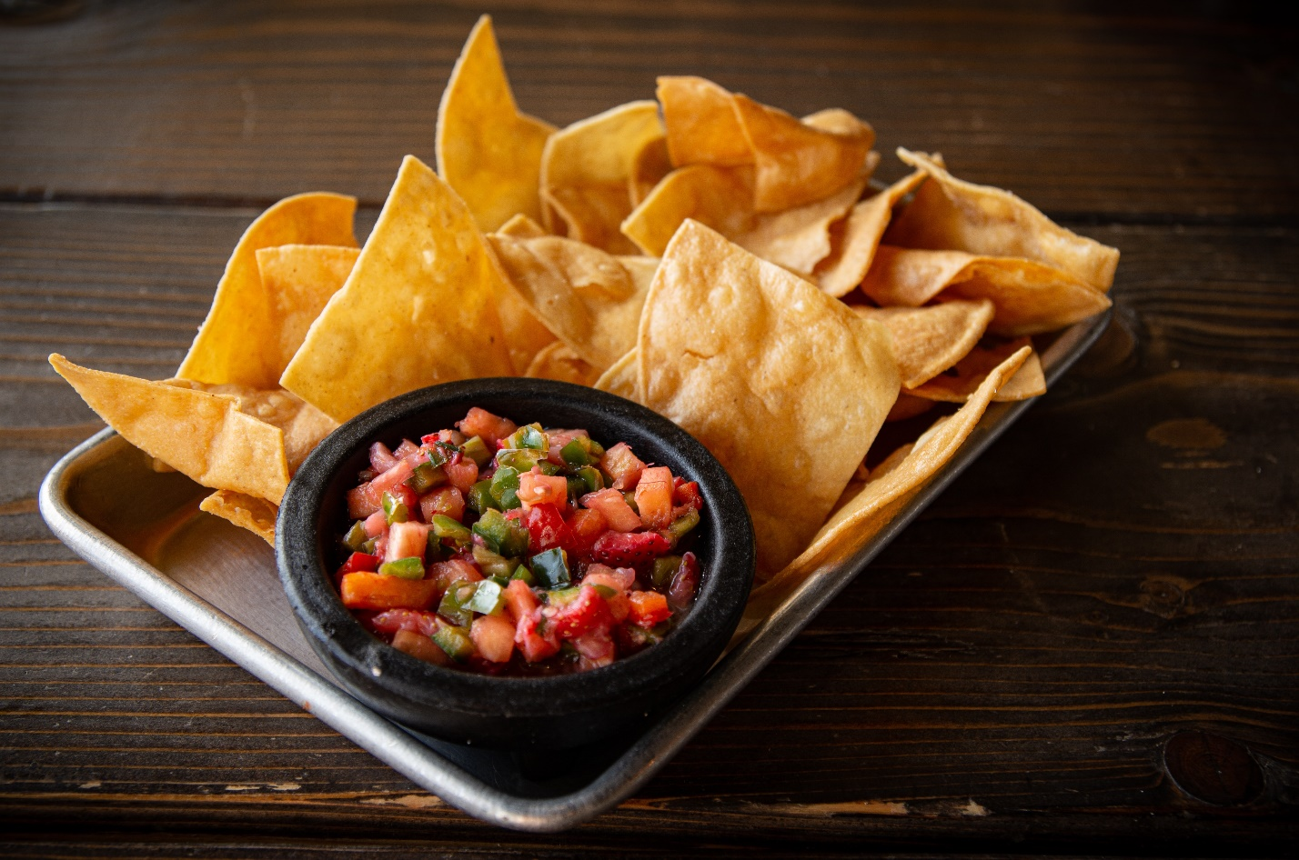

Figure 1 Splash image on landing page

The rough inspiration for layout/ responsiveness of the landing and menu pages was drawn from the site(s) below:

<https://tgcpoutinerie.com/>

## Platform

The requirements for this project was for the website to target traditional monitor resolutions of 1024 x 768 pixels and greater.

I have tried to incorporate additional layouts for additional screen sizes of 700px and 500px for the landing page, and 800px and 600px for the menu page.

CSS Grid Areas were used to position the elements on these pages.

## Semantic Design Guide

Major semantic elements used in the website:

### <head>

Used to link to stylesheet, declare fontstack, incorporate author information, and display browser window title.

Chosen font-family was Arial, Helvetica, sans-serif, to convey the casual feeling of the restaurant.

### <body>

Used to contain the main section of the webpage. Could be substituted for <main>.

Chosen colour schemes were picked around the splash image on the landing page (Figure 1). The following colours were used:

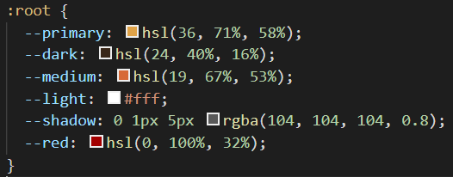

Figure 2 Colour Palette

### <div class= “wrapper”, “contactus”>

A generic <div> wrapper was chosen to contain all elements inside the <body>, in order to act as a container to be targeted by the CSS “display: grid” and “grid-template-areas” attributes.

### <nav>

Used to display the common navigation bar across the website.

### <section class= “boxes”, “menu”, “menu-boxes”, “history”, “reservation”>

Used to create segmented elements for placement on grid.

### <table class= “contact”>

Used to display schedule with opening hours.

### <footer>

Used to contain copyright information.

## Website Map

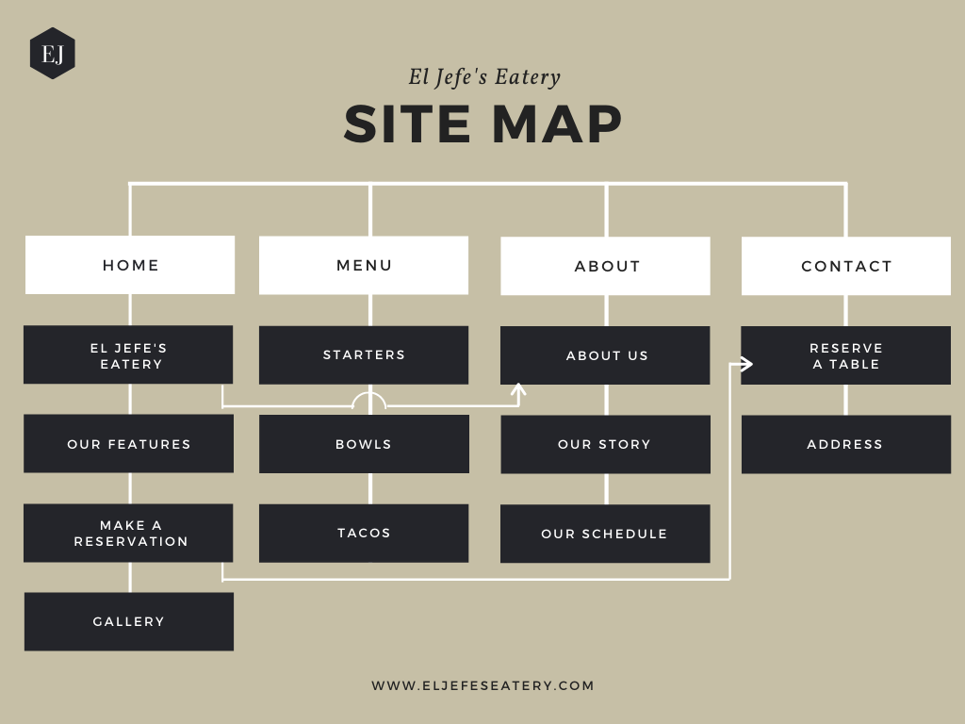

Created using <https://www.canva.com/graphs/site-maps/>